The Infrastructure Architecture  
The Environment Model

This intention is to provide suitbe infrastructure to deliver a micro-service application.  
There are various technologies to be considered depending on where the software for this project will be deployed.

* The project is written as a Spring boot Micro service . Instead of delivering the project a s a JAR file it is delivered as a WAR file.

**This give us two options for the deployment of the project and hence the infrastructure**

1. Cloud infrastructure
   * Amazon Cloud
   * Google Cloud
   * Microsoft Azure Cloud
2. Web Server infrastructure
   * The recommended Webserver to use here is Apache tomcat

**The following Network Topology diagram describes the infrastructure to run in a Webserver**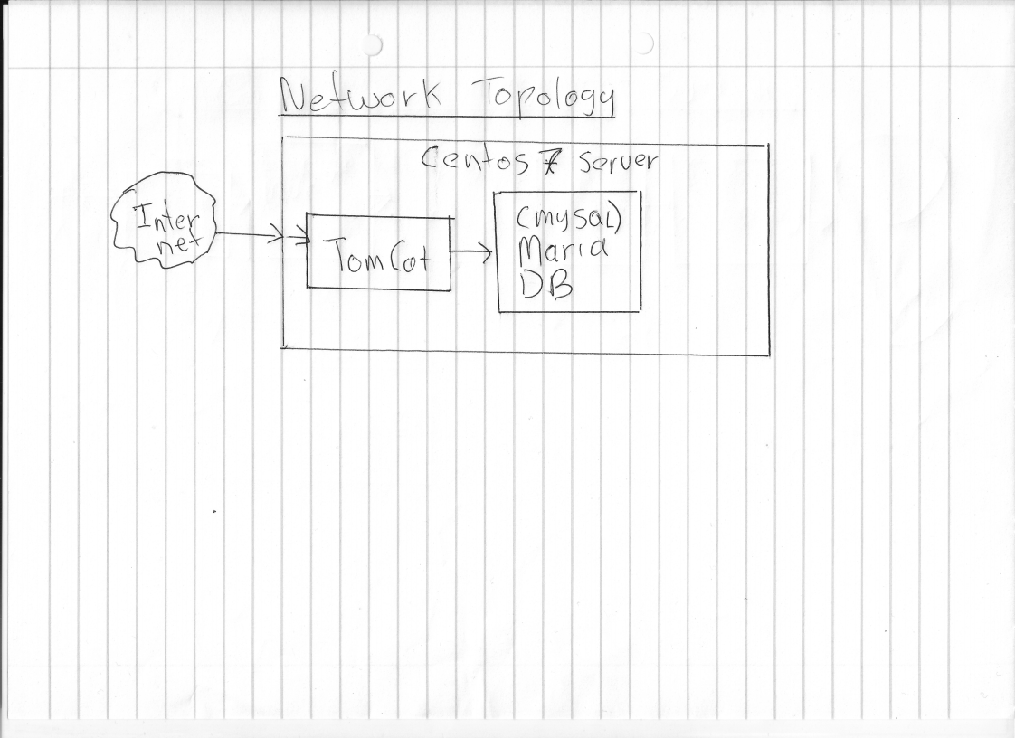

**The following technologies will be used:**  
  
Operating System : Centos7  
Java JDK : Open JDK 11: openjdk version "11.0.9.1" 2020-11-04  
Database : Maria DB: Server version: 10.5.8-MariaDB-1:10.5.8  
Web Server: Apache Tomcat: Version 9.0.37  
  
**Other technologies to be considered:**  
Docker : Should we want to deploy to the Cloud  
Kubernetes: To manage Docker containers in a scalable Enterprise environment